**Xi’an**

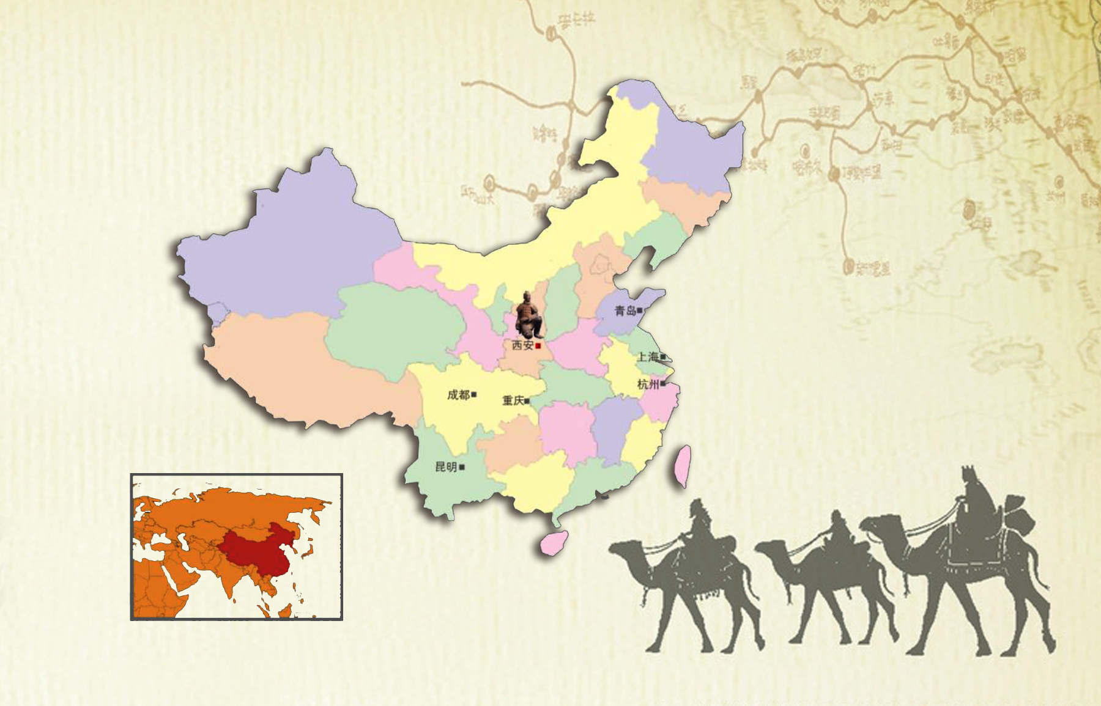

Xi'an is a famous historical and cultural city in China. It is the cradle of the Chinese nationality, the birthplace of the Chinese civilization and the representative of the Chinese culture. The city was first established more than 3100 years ago and it has been taken as a capital for 1129 years for 13 dynasties. It is one of the most ancient capitals of the world, in the company of Athens, Rome, and Cairo. The city once functioned as the political, economic, and cultural center of China and as the starting point of the renowned Silk Road. Due to its long history and rich culture, the city is reputed to be the natural history museum.

**Qujiang New District (http://www.qujiangtour.com.cn/English/Home.htm)**

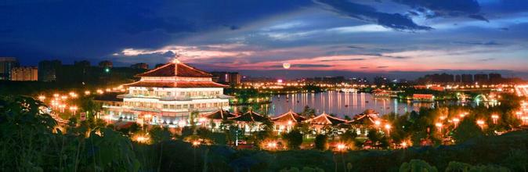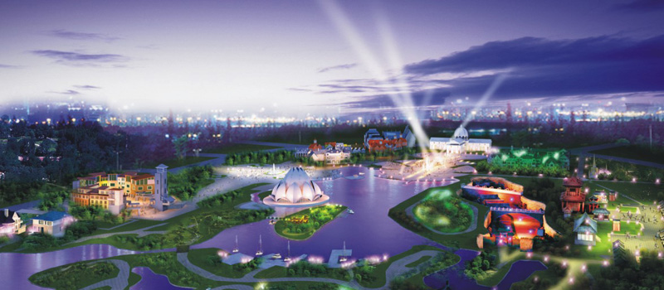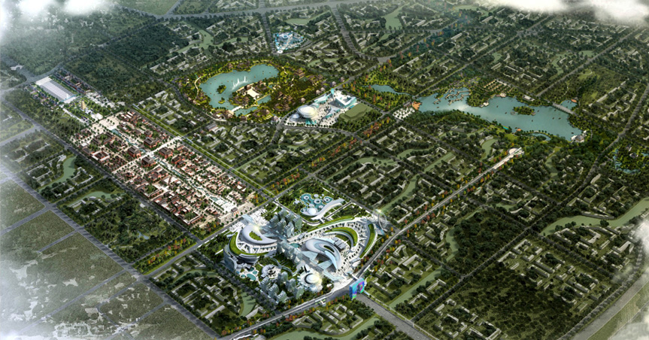

The conference will be held in the Qujiang New District of the Xi’an city. This district was the royal garden in China’s Qin Dynasty and Tang Dynasty. Now it is the most active district reflecting the culture, art, creation and innovation.

Attractions：这是申请会议和中期汇报时用的中英文地图（比如Google地图），上面标有各个景点的位置。

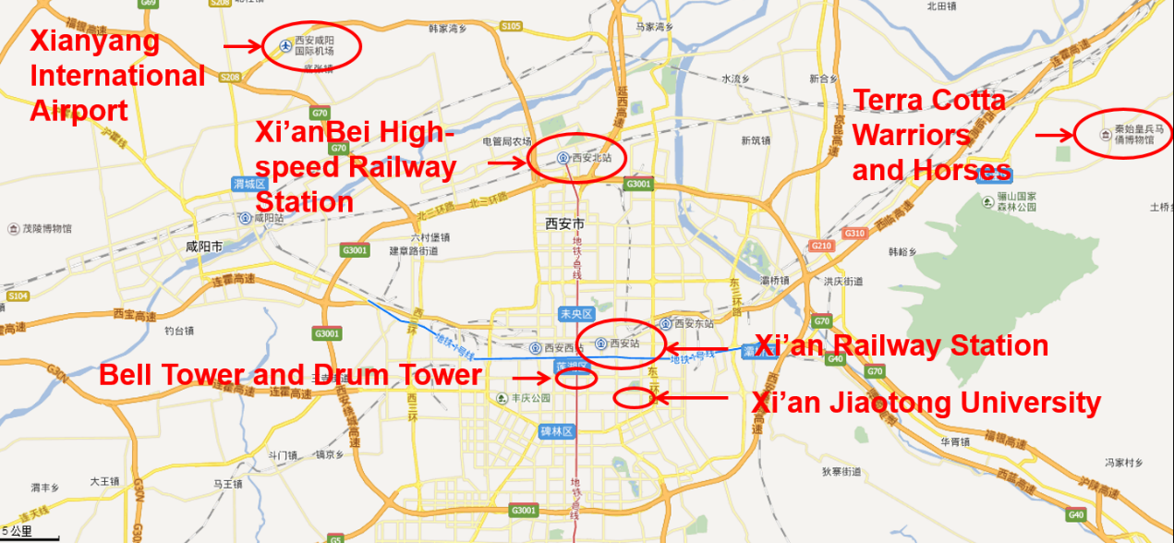

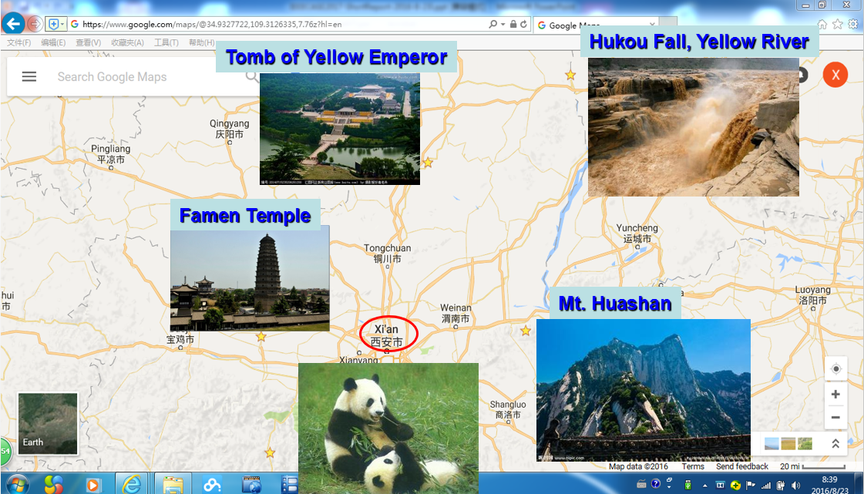

**Tranfic**

Xianyang International Airport (http://www.xxia.com/)

Distance: 44km

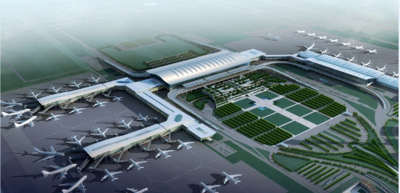

Xi'an Xianyang International Airport is the main airport serving Xi'an. Covering an area of 5 square kilometres (1.9 sq mi), it is the largest airport in China's northwest. The airport was the hub for China Northwest Airlines until the company was merged into China Eastern Airlines in 2002. Xi'an Airport is also the hub for Joy Air and a focus city for Hainan Airlines. In 2014, the airport handled 30,040,654 passengers, making it the busiest airport in northwest China and the 8th busiest nationwide. Xi'an Xianyang International Airport was also the nation's 14th busiest airport in terms of cargo traffic and the 9th busiest airport by traffic movements.

**Xi’an Railway Station**

Distance: 8km

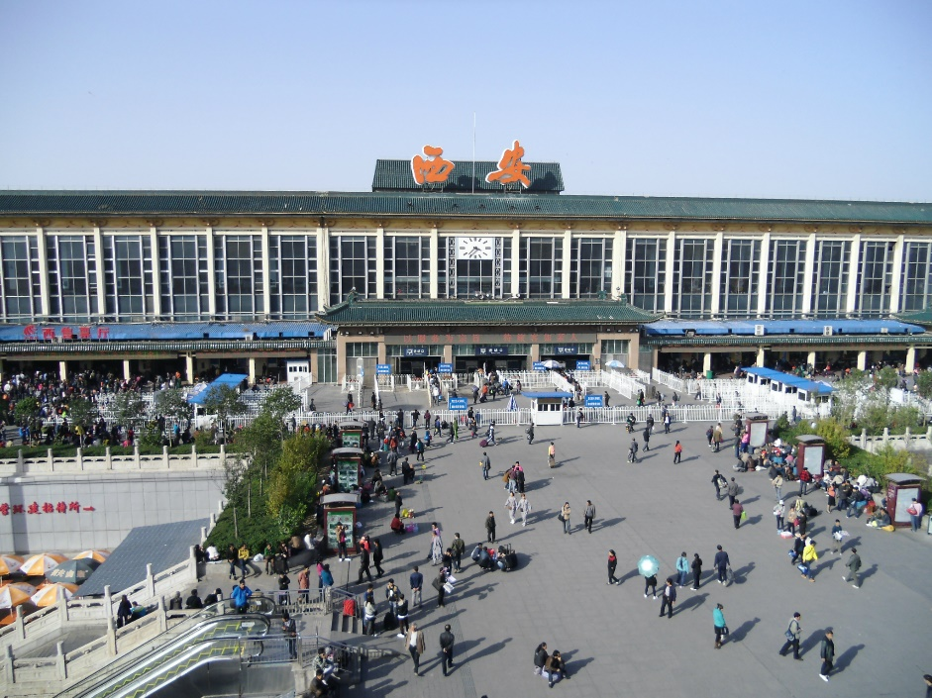

Xi'an Railway Station is one of the two main railway stations of Xi'an, located on the Longhai Railway line, just north of Xi'an's historical walled city. Xi'an Railway Station had long been *the* main train station of the Xi'an metropolitan area. It now remains the main station for all "conventional" rail service in the city, including the overnight Z-series expresses, T-series express trains, and all slower service.

**Xi’an Bei High-speed Railway Station**

Distance: 23km

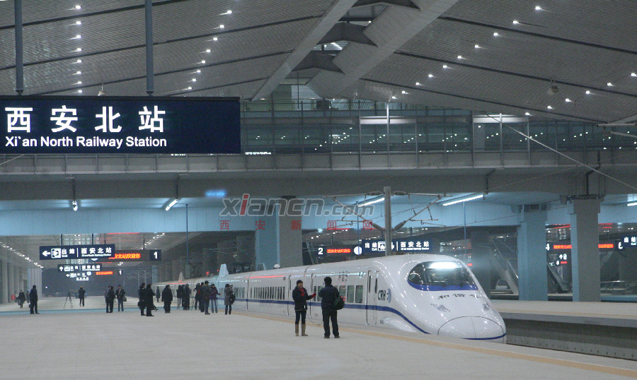

The Xi'anBei Railway Station is located in the northern outskirts of Xi’an City. It is about 10 km north of the city center and the Xi'an Railway Station. The station is connected to downtown Xi'an by Line 2 of Xi'an Metro. ,

This station is the largest railway station in Asia. The station currently has 34 platforms, providing high-speed railway services, including the G- and D-series trains.

**Attractions**

**Terra Cotta Warriors and Horses (http://www.bmy.com.cn/2015new/index.htm)**

Distance: 42km

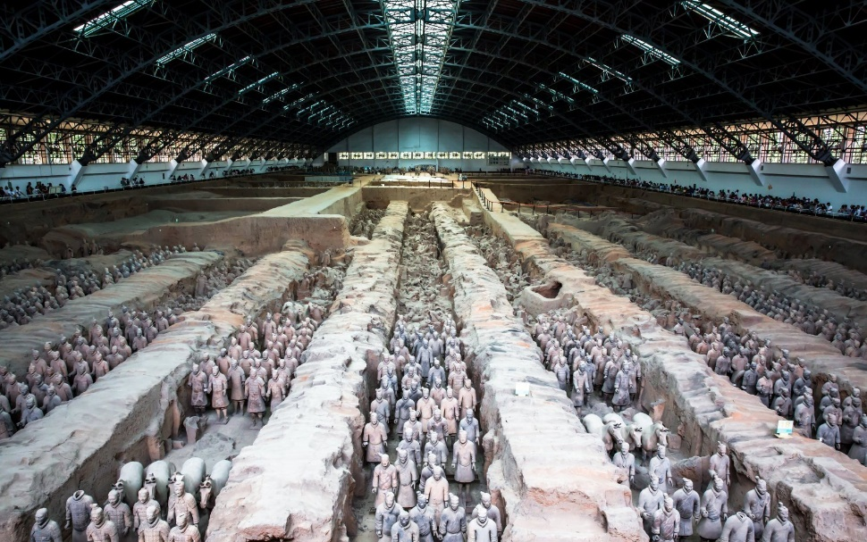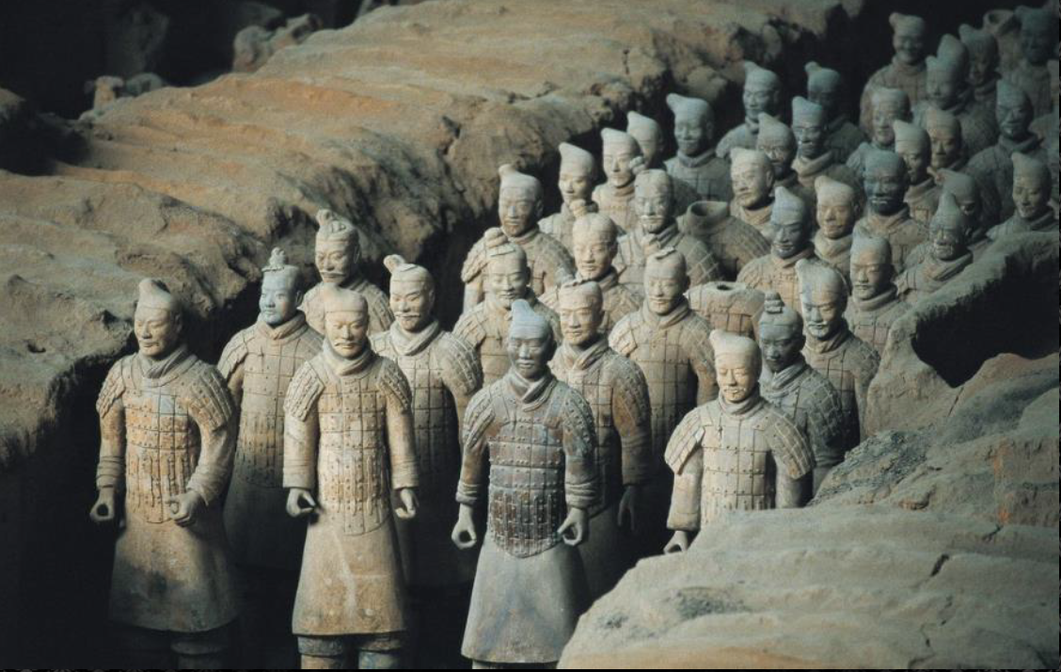

The museum of Terracotta Warriors and Horses is a worldwide famous historic resort. It is a collection of terracotta sculptures depicting the armies of Qin Shi Huang, the first Emperor of China. Terracotta Warriors and Horses were buried with the emperor to be expected to protect the emperor in his afterlife. This is a classic form of funerary art.

The figures, dating from approximately the late third century BCE, were discovered in 1974 by local farmers in Lintong district of Xi'an. The figures vary in height according to their roles, with the tallest being the generals. The figures include warriors, chariots and horses. It is estimated that the three terracotta army pits contain more than 8,000 soldiers, 130 chariots with 520 horses and 150 cavalry horses, and the majority of which remained buried in the pits nearby Qin Shi Huang's mausoleum. Other terracotta non-military figures were found in other pits, including officials, acrobats, strongmen and musicians.

**Big Wild Goose Pagoda**

Distance: 2km

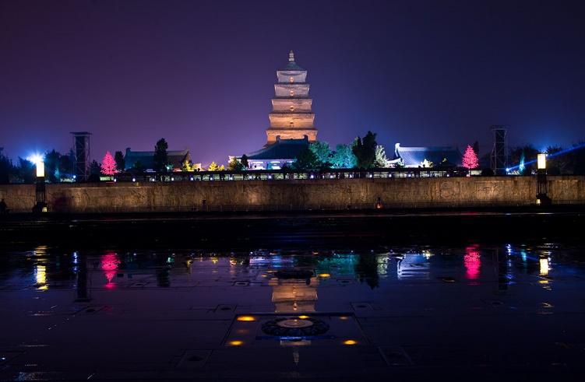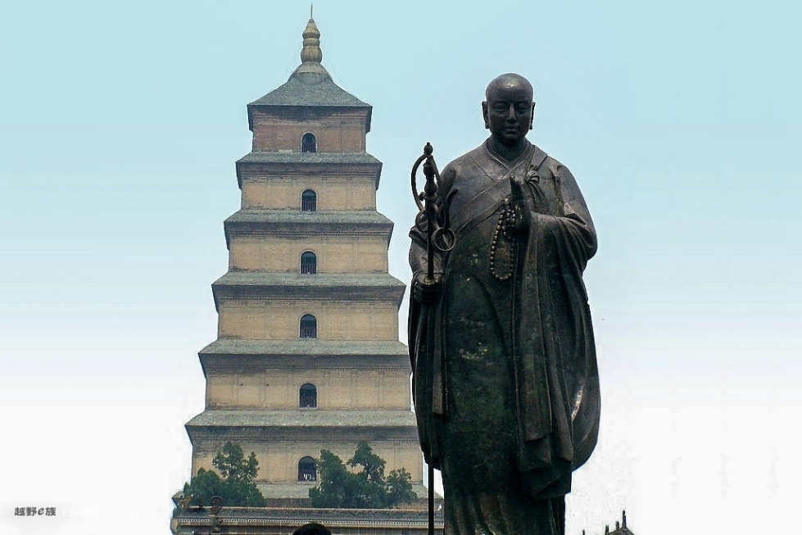

Big Wild Goose Pagoda is a Buddhist pagoda, located in southern Xi'an. It was built in 652 during the Tang Dynasty (618-907) to store the sutras and figurines of the Buddha that were brought to China from India by the Buddhist Master Xuanzang.

**City Wall of Ming Dynasty**

Distance: 6km

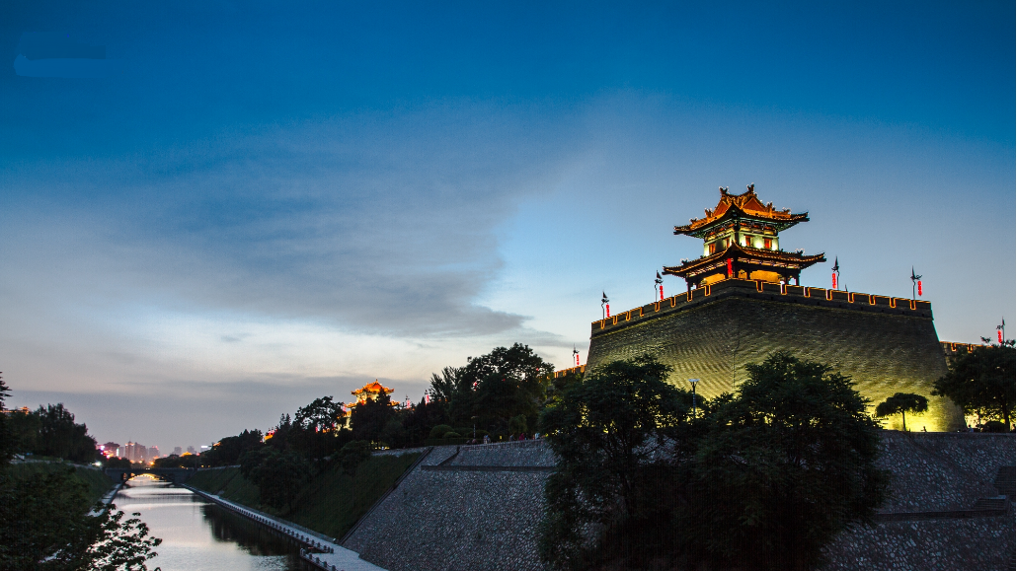

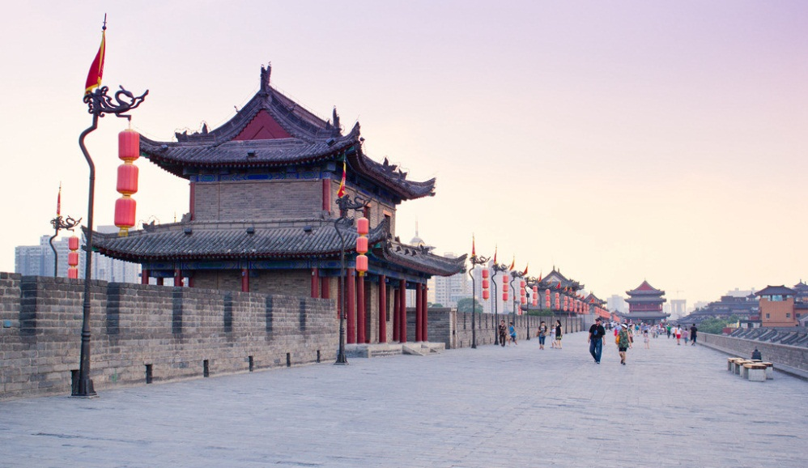

The Xi’an City Wall was originally built in the Ming Dynasty (1368-1644) as a military defensive system. The wall stands 12 meters tall, 12-14 meters wide at the top and 15-18 meters thick at the bottom. It stretches 13.7 kilometers with 98 watchtowers on the wall. It's the most complete city wall that has survived in China, as well being one of the largest ancient military defensive systems in the world.

**The Bell Tower and Drum Tower**

Distance: 5km

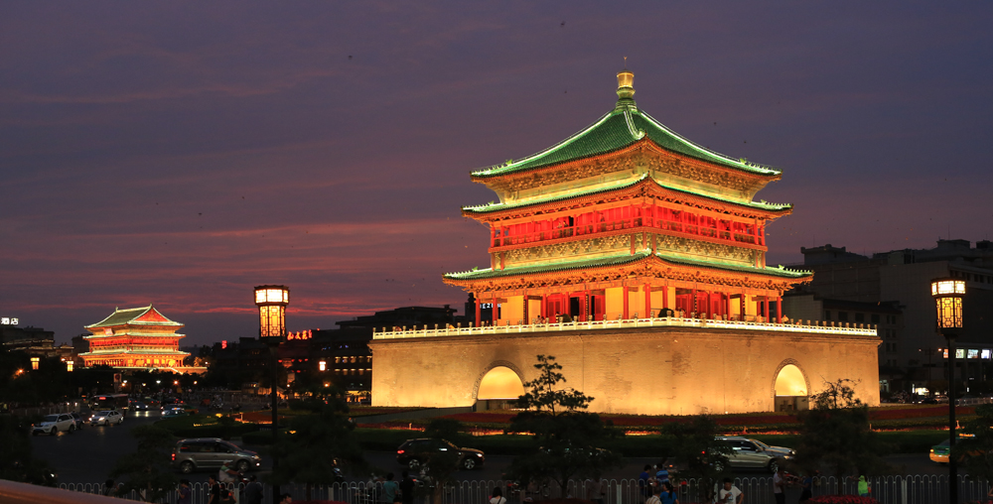

The Bell Tower and Drum Tower, located in the heart of the City, were built respectively in 1384 and 1380 during the early Ming Dynasty. The Bell Tower contains several large bronze-cast bells made in Tang Dynasty. Every day the bell was stricken at dawn to indicate the start of the day. The Drum Tower got its name from the huge drum located within the building. The drum was beat at sunset to indicate the end of the day. Now the Bell Tower and Drum tower are the symbols of Xi'an.

**Xi’an Beilin Museum（http://www.beilin-museum.com/）**

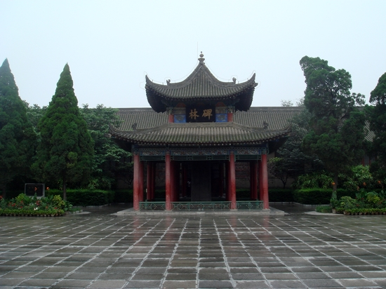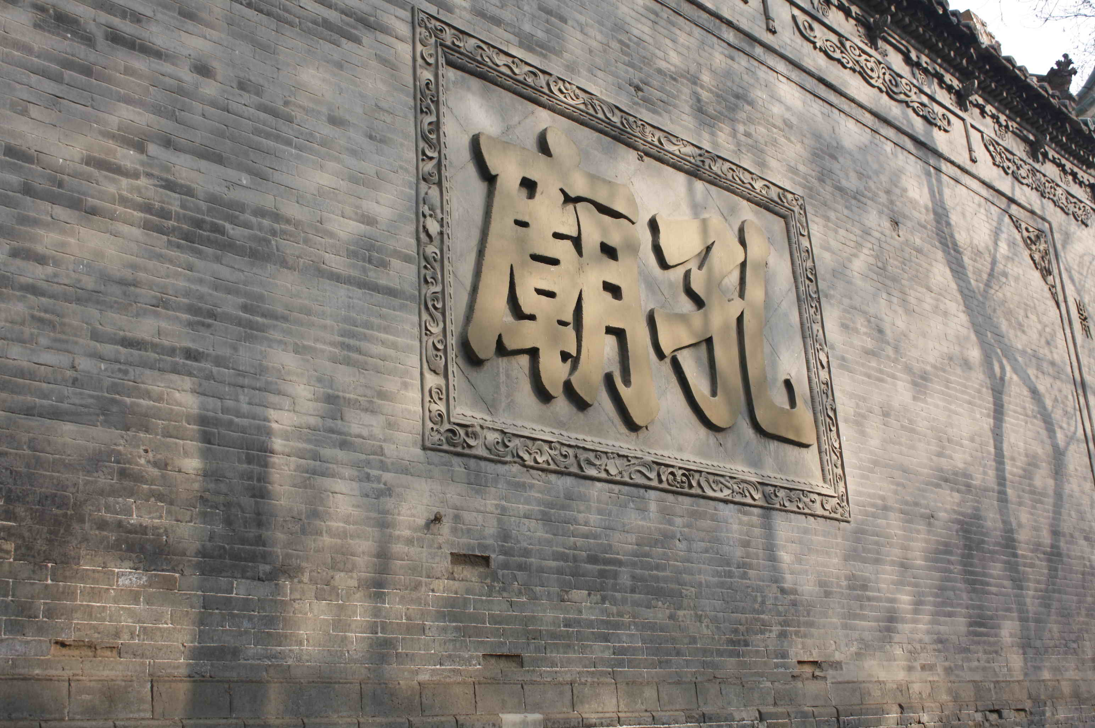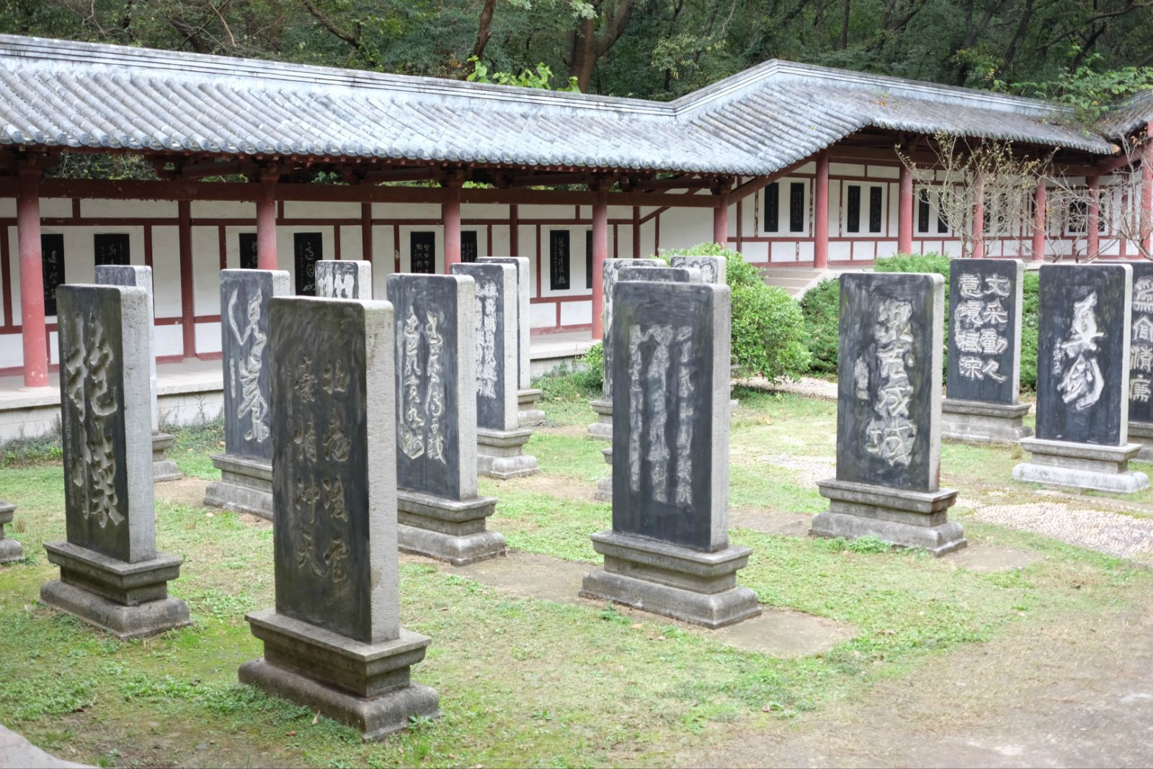

This is a museum of forest of stone tablets, located at the site of Confucian temple in Xi’an. This museum was set up in 1087 and it collected more than 3000 stone tablets from the Han dynasty through the Qing dynasty. The whole area consists of 3 parts: Confucian temple, exhibition of stone tablets and stone carvings.

**Qujiang Pool Relics Park**

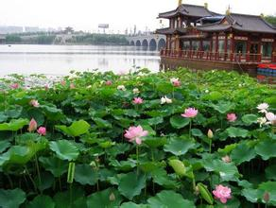

Qujiang Pool Relics Park is adjacent to the Tang Paradise, Qujiang Hanyao Relics Park, Emperor Qin Ershi Mausoleum Relics Park, and Tang Dynasty Wall Site Park. It covers an area of more than 1000 acres, over 700 acres of which is water area. These parks constitute a large urban ecological and cultural amusement zone in Xi’an.

**Famen Temple (http://www.famensi.com/)**

Distance: 120 km

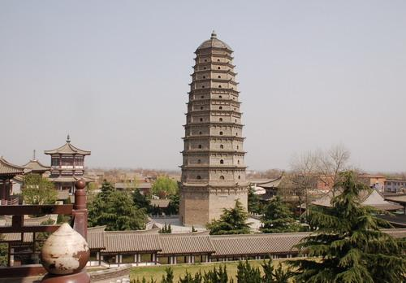

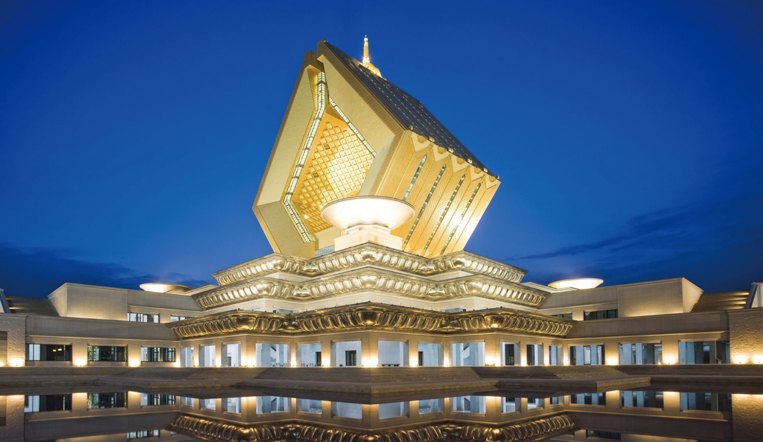

Famen Temple is located in Famen town, Fufeng County, 120 kilometers west of Xi'an.

In May 1987, four relics claimed to be directly related to Buddha were found in after the opening of an underground palace of the temple. They were declared by experts to be a finger bones of the Sakyamuni Buddha. Thereafter, Famen Temple became a Buddhist place of pilgrimage due to the discovery of what is claimed as a true relic of Buddha.